1. Configuration method
Web set up
You can customize relevant parameters through web settings. Open a browser, enter the device IP address in the address bar (default: 192.168.3.7), and go to the page to query and set parameters. Finally, click the "Submit" menu and wait for the success prompt to take effect.
Note: Do not access web configuration during normal use, as it may cause data loss. If you enter web configuration, you must restart the device to return to communication mode.
Web page configuration initial password: 123456. You can customize it, but only supports 6-digit alphanumeric characters.
The web configuration requires browsers with newer kernel versions for proper functionality, such as Microsoft Edge (96.0.1054.62), Google Chrome (96.0.4664.110), Firefox (95.0.2), and similar versions.
[Note] Web page configurations are not supported for browsers using the IE kernel, such as IE, 360 Compatibility Mode, and QQ Browser Compatibility Mode.

Configure software settings
Open the configuration tool software, search for the device, and double-click the recognized device to open the parameter query and configuration interface. You can customize and modify relevant parameters as needed, then save the configuration, restart the device, and complete the parameter changes.
【 pour 】：
Do not use multiple host computers in the same LAN environment. Multi-network card industrial control computers must temporarily disable unused network cards; otherwise, host computers may fail to detect devices properly (such as repeated device display or device detection failures).
The host computer blocks the wireless network card, so you must connect it via an Ethernet cable. The wireless network card can be configured through a web interface.

AT command configuration
You can configure device parameters via AT commands. Refer to the specific AT commands for details.
“NA11x&NT&NS-AT instruction set”

Web configuration
- Configuration method: Web configuration
The device comes with a built-in web server, allowing users to configure and query parameters via web interfaces.
The web server port can be customized (2-65535). Default: 80
Operation method (using Microsoft Edge version 94.0.992.50 as an example; Google Chrome is recommended and IE-based browsers are not supported):
Open a browser and enter the device's IP address in the address bar, such as 192.168.3.7 (ensure the IP address matches the computer's network segment). If you forget your local IP address, you can check it using AT commands or configuration software.

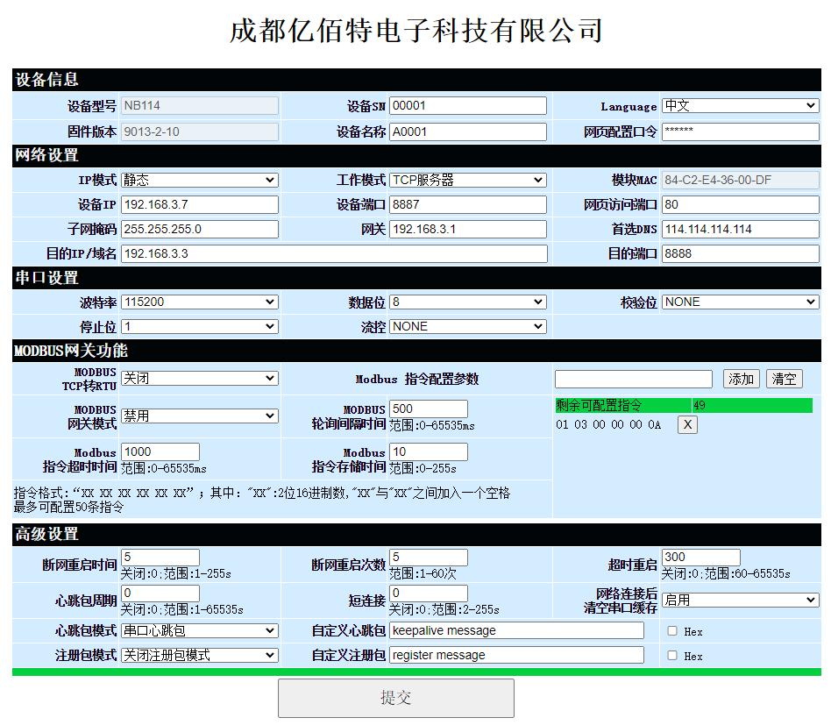
The webpage displays the main interface, where you can query and configure relevant parameters.
Click Submit. After entering the correct key, you can save the configuration parameters. The default key is 123456.
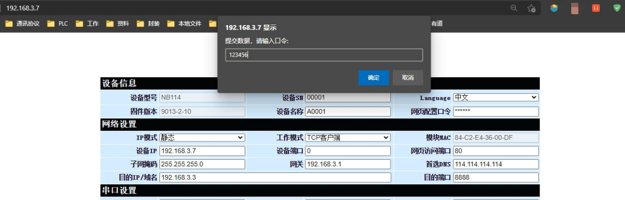
The progress bar displays configuration status. After completing the setup, avoid refreshing the webpage (doing so may force the system back into configuration mode).

You can restart the device or resubmit to enter communication mode.
It can also be accessed by configuring the web page access button in the software settings.
[Note] If you modify the port number, include it in the address field. For example, if you change the web access port to 8080, enter 192.168.3.7:8080 in the address bar for web configuration.
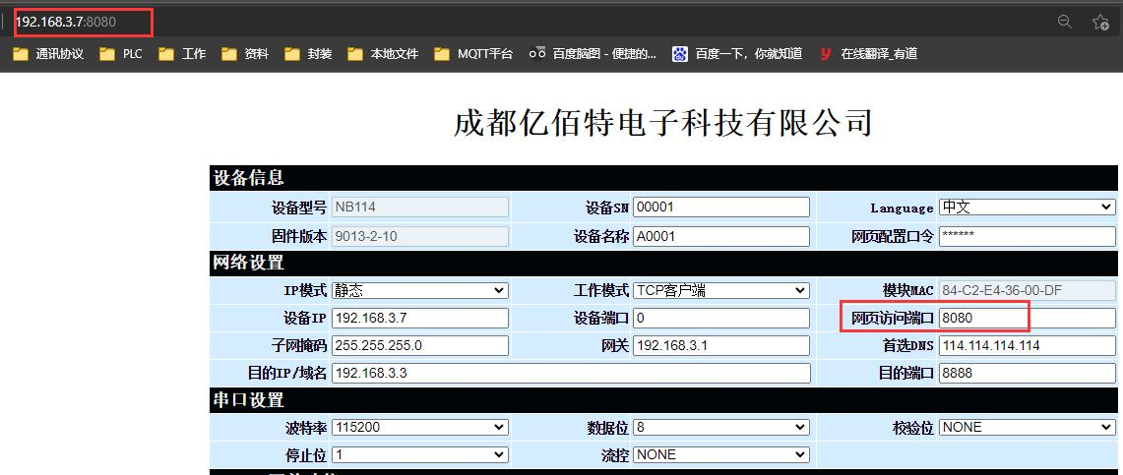
- Subnet mask/IP address
An IP address serves as the identity identifier for a module within a local area network (LAN), ensuring uniqueness and preventing duplication with other devices in the same network. Modules can obtain IP addresses through two methods: static IP allocation or DHCP (Dynamic Host Configuration Protocol).
(1) Static IP: Static IP requires manual configuration by users. During setup, ensure simultaneous entry of IP address, subnet mask, and gateway information. This approach is ideal for scenarios requiring IP device statistics and one-to-one correspondence.
Advantages: Devices without assigned IP addresses can be detected through whole-network broadcast mode, enabling centralized management.
Disadvantages: Different LANs have distinct internal segments, which prevents normal TCP/UDP communication.
(2) Dynamic DHCP: The primary function of DHCP is to dynamically obtain IP addresses, gateway addresses, and DNS server addresses from the gateway host, thereby eliminating the cumbersome steps of manual IP configuration. This approach is suitable for scenarios where IP requirements are minimal or where a one-to-one correspondence between IP addresses and modules is not mandatory.
Advantages: Devices with DHCP servers (e.g., access routers) can communicate directly, eliminating the need to configure IP addresses, gateways, and subnet masks.
Disadvantages: When connected to networks without DHCP servers (e.g., direct computer connections), the module will fail to operate properly.
The subnet mask is primarily used to determine the network address and host address of an IP address, indicate the number of subnets, and flag whether a module resides within a subnet.
Subnet masks must be configured. The commonly used Class C subnet mask is 255.255.255.0, where the network address occupies the first 24 bits, the host address occupies the last 8 bits, and the subnet count is 255. If a module's IP address falls within this range, it is considered to belong to this subnet.
A gateway refers to the network number of the module's current IP address. When connecting to an external network through devices like routers, the gateway becomes the router.

Network Mode Description
TCP Server Mode
A TCP Server refers to a device configured to operate in TCP Server mode. In this mode, the device monitors local ports, accepts client connection requests, and establishes connections for data communication. When the Modbus gateway function is disabled, the device transmits serial port data to all connected client devices, supporting up to 6 client connections. Upon enabling the Modbus gateway function, non-Modbus data will be cleared and not forwarded. This configuration is typically used for communication with TCP clients within local area networks.

TCP client mode
A TCP client is a device that actively requests and establishes connections with servers during operation to facilitate data exchange between serial ports and servers.
To use the client, you need to configure the target IP address/domain name and target port accurately.
UDP server mode
A UDP Server refers to a device that does not verify the source IP address when communicating via the UDP protocol. Upon receiving each UDP packet, the device records the source IP address and port, then sets them as the destination IP and port. Consequently, data packets are only transmitted to the source IP address and port where the device last received data. This mode is typically employed in scenarios involving frequent communication between multiple network devices and the host, where TCP Server cannot meet the required conditions.
To use UDP Server, the remote UDP device must first send data; otherwise, data cannot be transmitted properly.
[Note] In UDP mode, the network must transmit data packets smaller than 512 bits to devices; otherwise, data loss may occur.
UDP client mode
UDP Client is a connectionless transport protocol that provides simple, unreliable transaction-oriented data transmission services. It requires no connection establishment or termination, only the configuration of destination IP address and port number to send data to the recipient. This protocol is typically used in scenarios where packet loss rate requirements are not critical, data packets are small in size, transmission frequency is high, and data delivery must be directed to specified IP addresses.
In UDP Client mode, the device only communicates with configured remote UDP devices (target IP and target port).
In this mode, the destination address is set to 255.255.255.255. Sent data will be broadcast across the entire network segment, but the sending and receiving devices must have matching ports. The devices can also receive broadcast data.

HTTP client mode
This mode supports HTTP group packet functionality with GET and POST protocols. Clients can configure parameters like URLs and Headers, while the device (serial port server) handles packet grouping and transmission to enable efficient communication between serial devices and HTTP servers. For HTTP client mode, it is recommended to use random ports and enable short connections to conserve server resources.
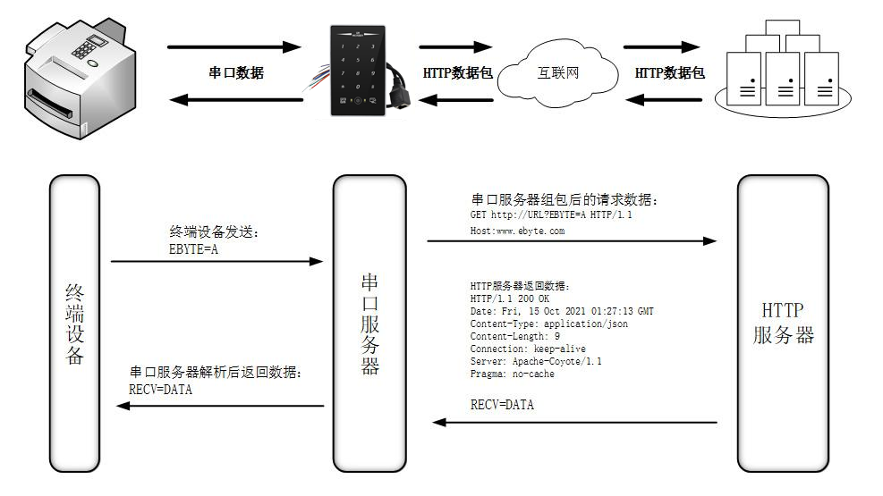
(1)GET
The HTTP mode utilizing OneNET multi-protocol access is employed to test the device's HTTP-GET requests, as illustrated in the figure below.
① Return data configuration with header:
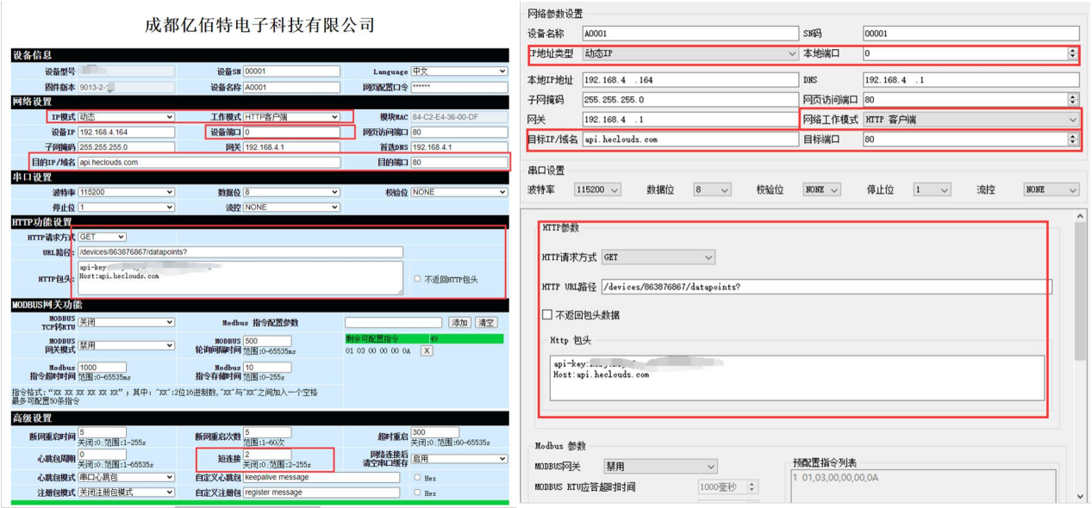
Data return test:
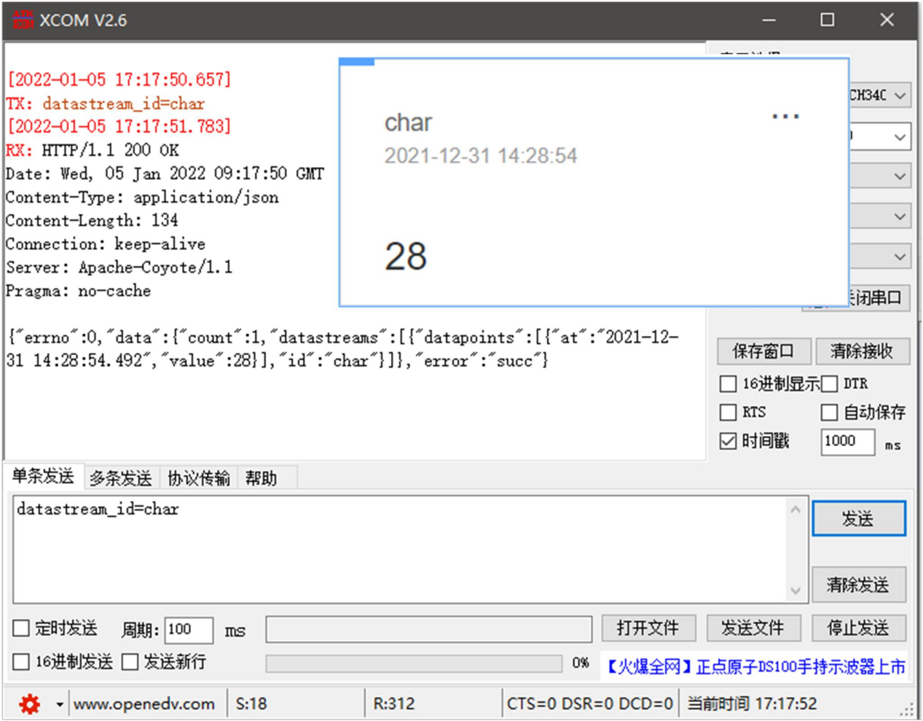
② Return data configuration without header:
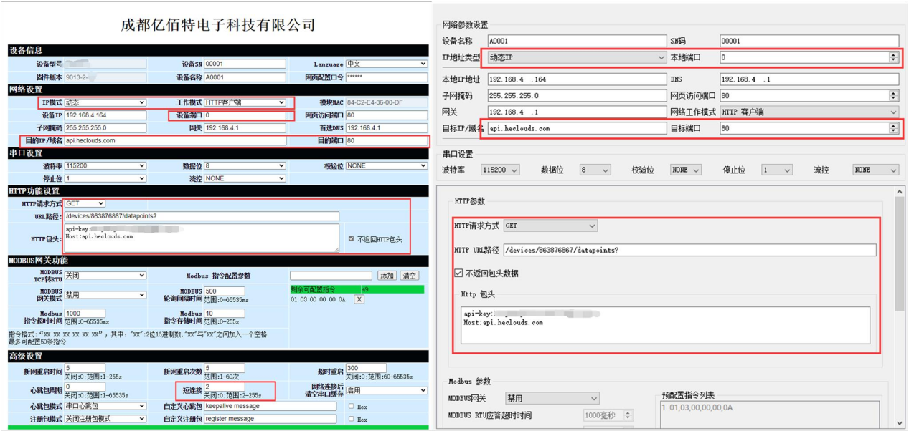
Data return test:
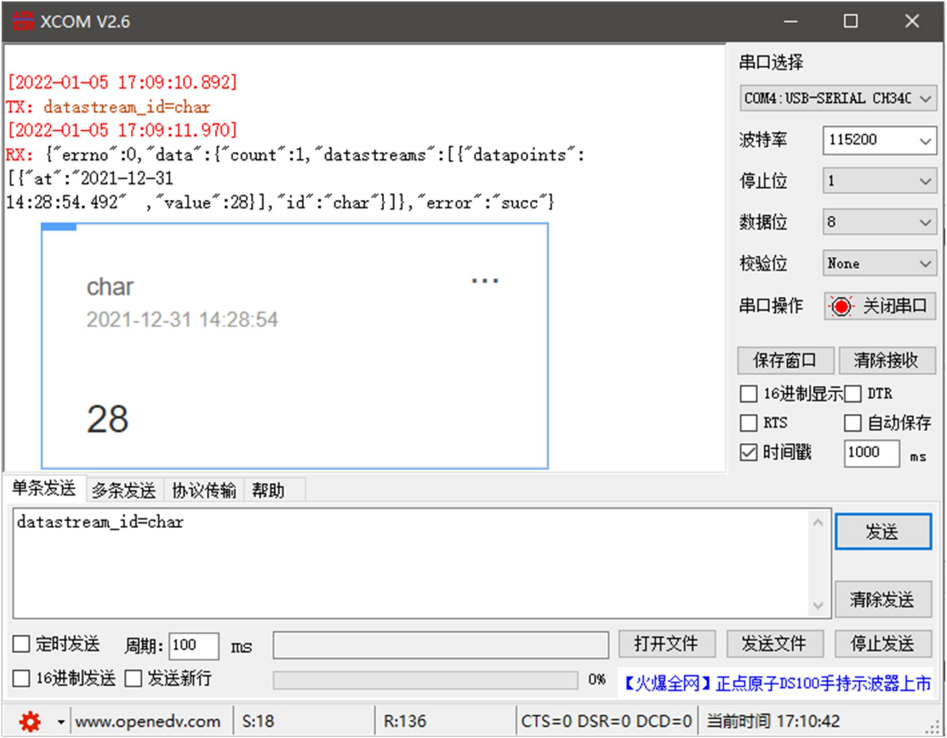
（3）POST
The HTTP-POST request of the testing device was tested using the HTTP mode with multi-protocol access via OneNET, as shown in the figure below.
① Return data configuration with header:
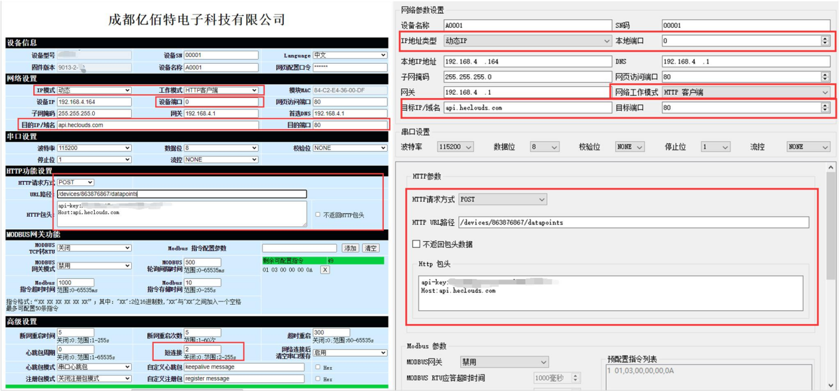
Data return test:
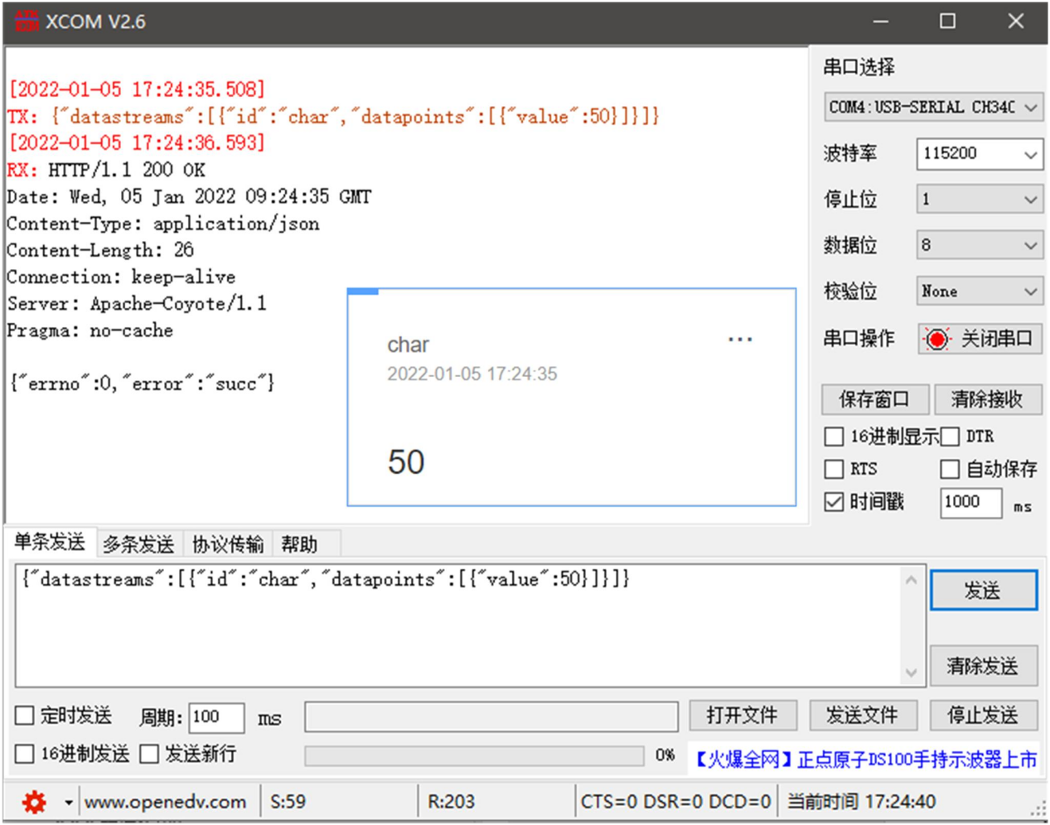
② Return data configuration without header:
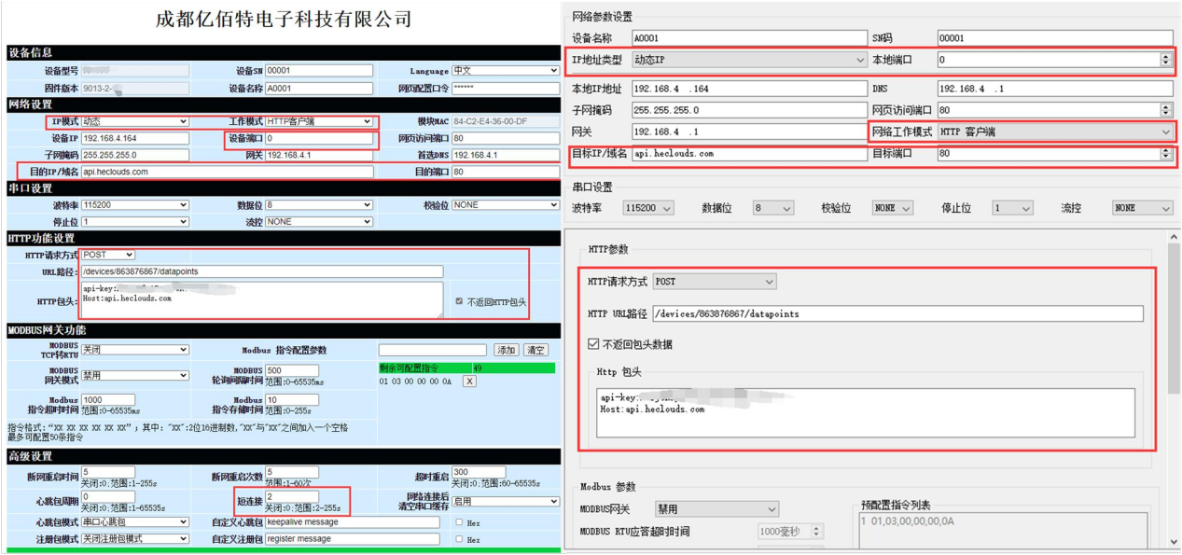
Data return test:
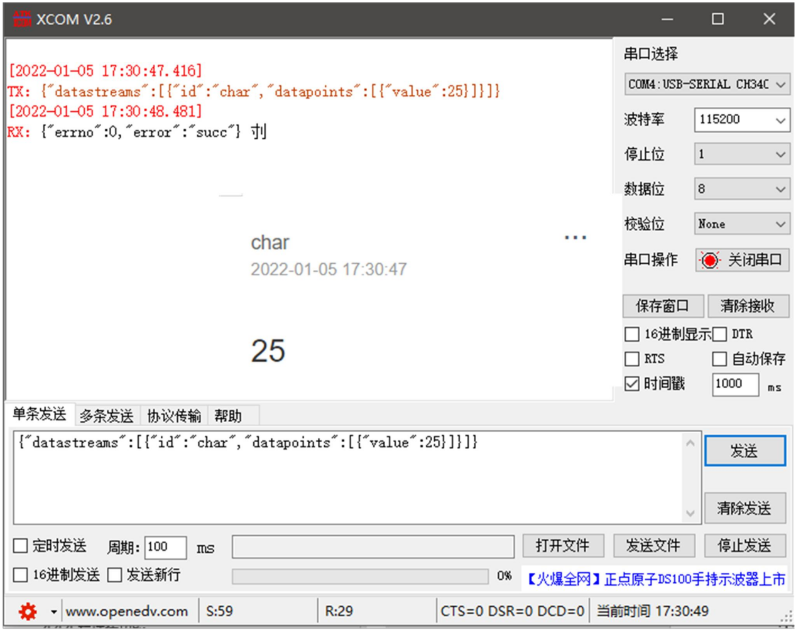
MQTT Client Mode
The serial port server supports fast access to standard MQTT3.1 protocol servers (including OneNET, Baidu Cloud, Huawei Cloud, and user-built server types) and Alibaba Cloud servers. It supports QoS level configuration (QoS 0, QoS 1) and ultra-long text configuration, facilitating better integration with network service providers (server addresses, three elements, and subscription/publication addresses support up to 128 characters).
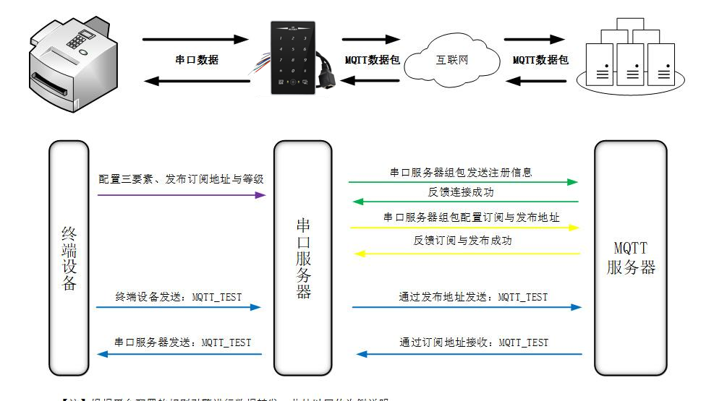
(1) Standard MQTT3.1.1
This section demonstrates the standard MQTT3.1.1 connection using Tencent's official MQTT3.1.1 server as an example, where standard data can be retrieved from the Tencent server.
The quasi-descriptive "three elements" are illustrated as follows:
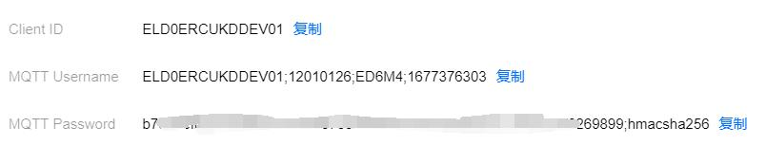
The parameter configuration (host computer and web interface) is illustrated as shown below:
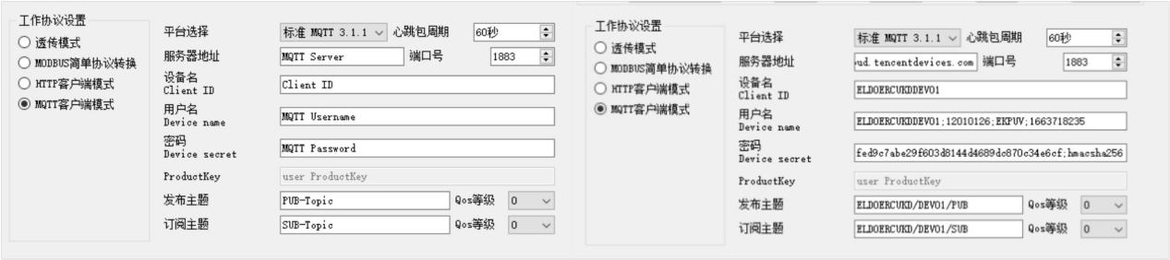
Configure the corresponding subscription publishing address and use the platform's online debugging feature to send data for communication testing:
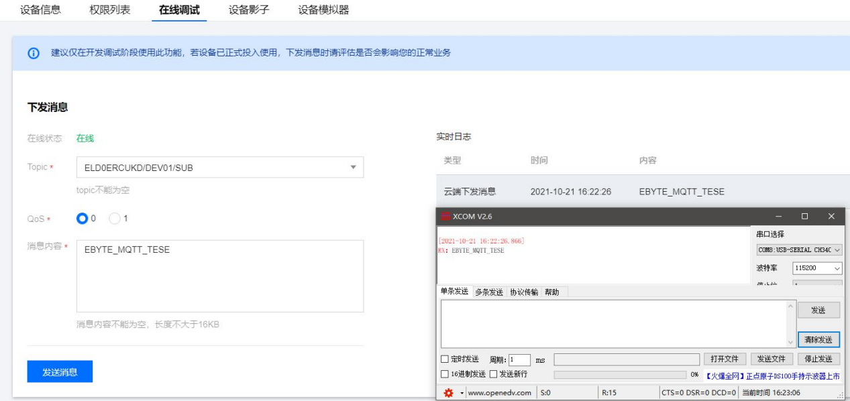
(2) Alibaba Cloud
Supports direct server connection using Alibaba Cloud's "Three Elements" to obtain the required credentials for connecting to Alibaba Cloud, as shown in the figure:
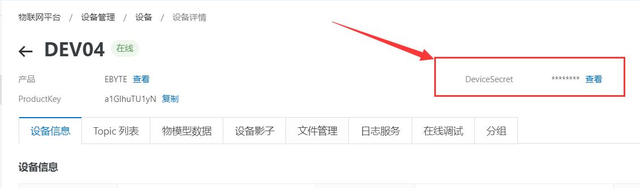
Configure Topic for communication testing:
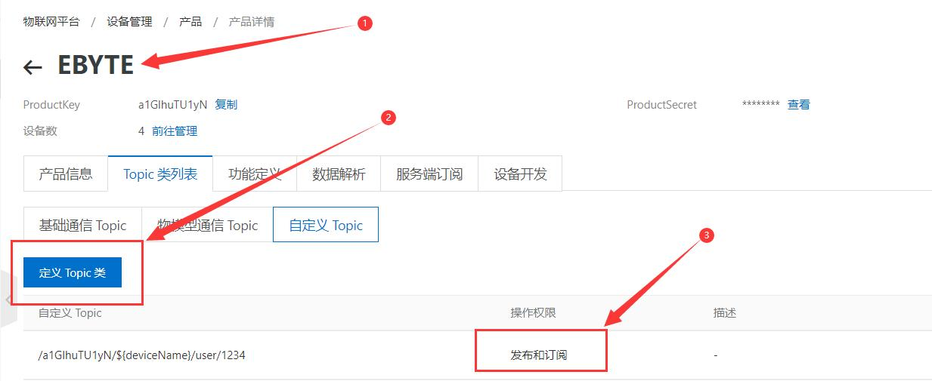
Select the appropriate product from the 'Custom Topic' section under the Topic category list (refer to Alibaba Cloud documentation for details).
Click "Define Topic Class", configure the name as 1234, and assign publish and subscribe permissions (for data feedback).
Configure device connection parameters as shown below:
{
"ProductKey": "a1GlhuTU1yN",
"DeviceName": "DEV04",
"DeviceSecret": "xxxxxxxxxxxxxxxxxxxxxxxxxx"
}
Ali Cloud server address: ProductKey. iot-as-mqtt.cn-shanghai.aliyuncs.com: 1883
Subscribe to and publish topics: /a1GlhuTU1yN/DEV04/user/1234
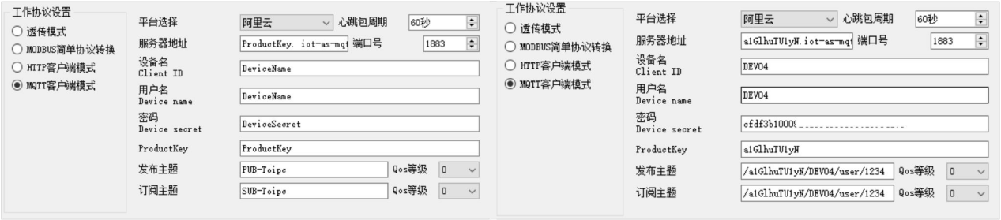
Ali Cloud MQTT Platform Communication Test:
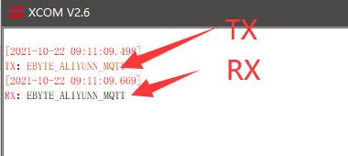(3) Baidu Cloud
Supports direct server connection using Baidu Cloud's "three elements" to obtain the required credentials for connecting to Baidu Cloud, as shown in the figure:
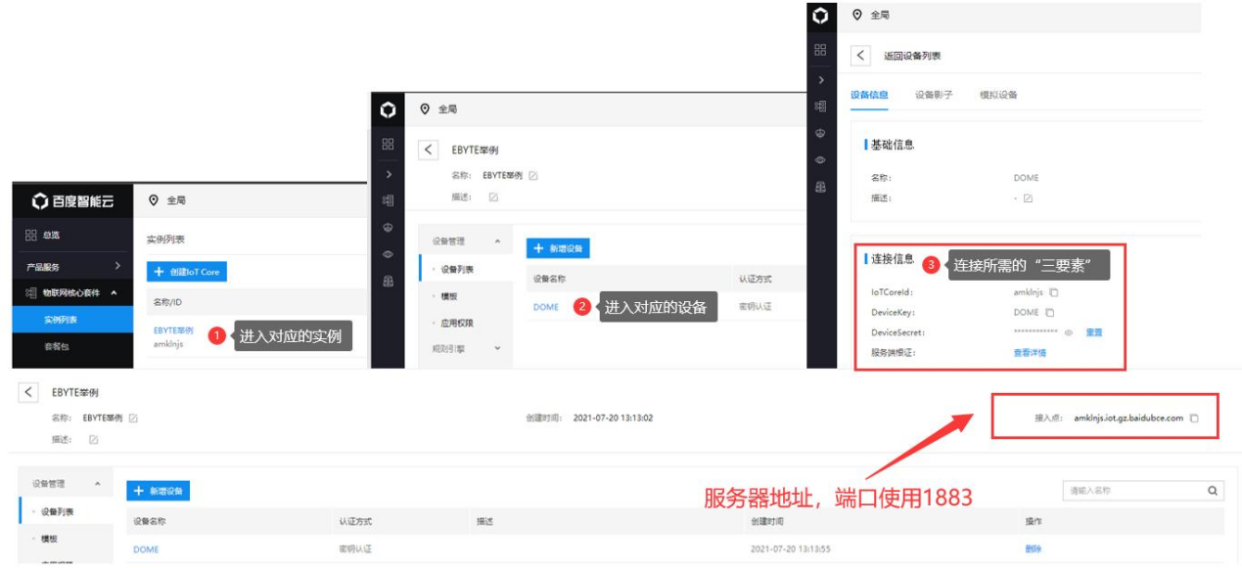
Configure device connection parameters as shown below:
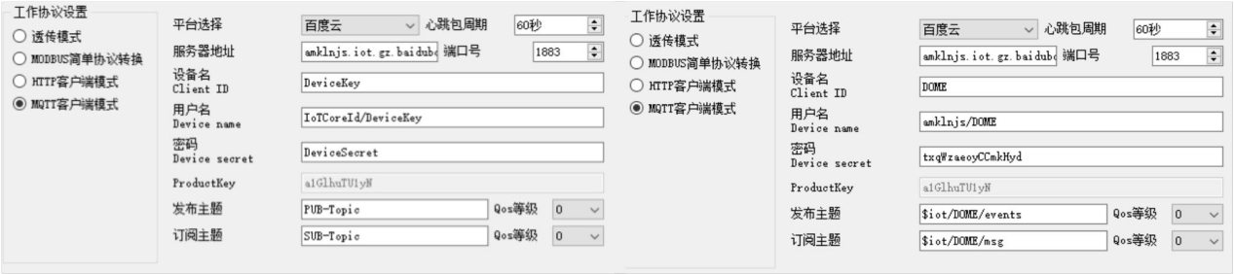
Subscription and publishing require a rule engine to enable data feedback. First, create a message template as shown below:
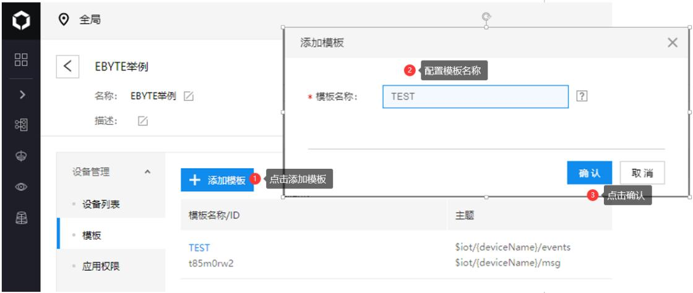
Create a rule engine for data feedback, as shown in the figure below:
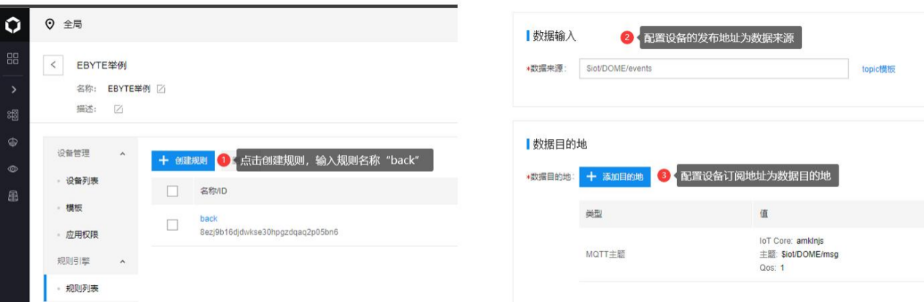
Enable the rule engine and restart the device (re-subscribe or publish). The communication test is shown below:
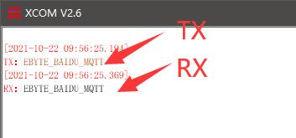
（4）、 OneNET
Supports direct server connection using OneNET's "three elements" to obtain the required components for OneNET connection, as shown in the figure:
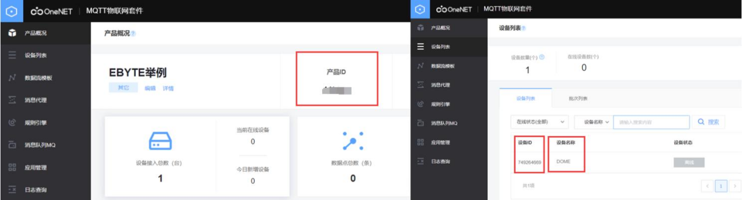
Configure device connection parameters as shown below:
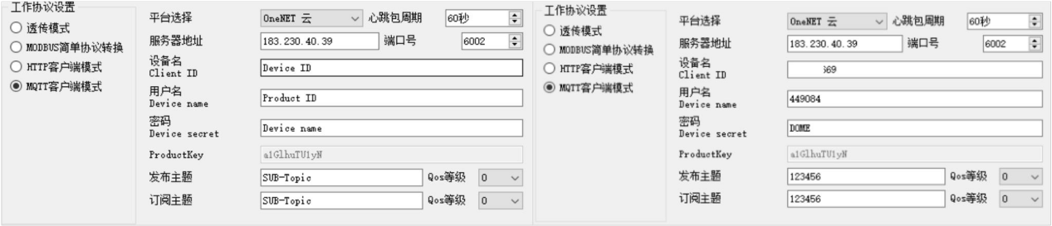
Server address: 183.230.40.39:6002 (Check the information for availability. Platform adjustments may cause connection issues)
Device name: Enter the OneNET device ID;
Username: Enter the OneNET product ID;
Password: Enter the device name (MQTTS) and the user-defined key (for MQTT with multi-protocol access).
OneNET supports automatically generating Topics with subscription-publishing attributes. Data feedback can be achieved simply by subscribing to the same address. Communication test:
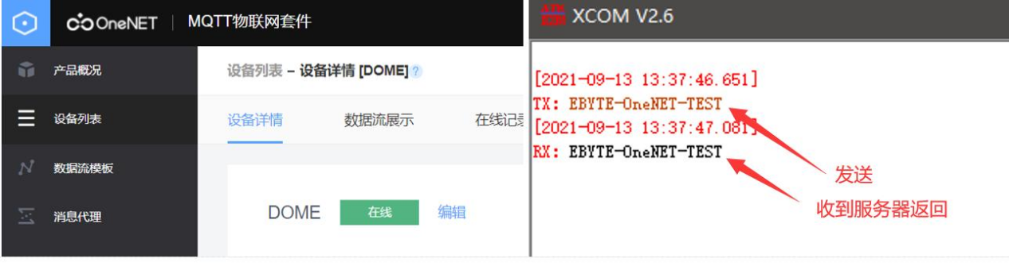

Modbus gateway
Modbus RTU to Modbus TCP Protocol Conversion
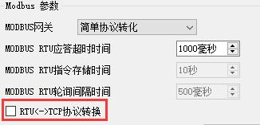
Enable: Convert between Modbus RTU and Modbus TCP protocols.
Disabled: Does not perform protocol conversion but verifies Modbus data, while discarding and not transmitting non-Modbus data (RTU/TCP).
Convert Modbus RTU data to Modbus TCP data or vice versa, enabling seamless conversion between Ethernet Modbus and serial port Modbus data.
The simple protocol conversion can operate in any mode (TCP client, TCP server, UDP client, UDP server, MQTT client, or HTTP client), and only one Modbus master station can exist regardless of the mode.
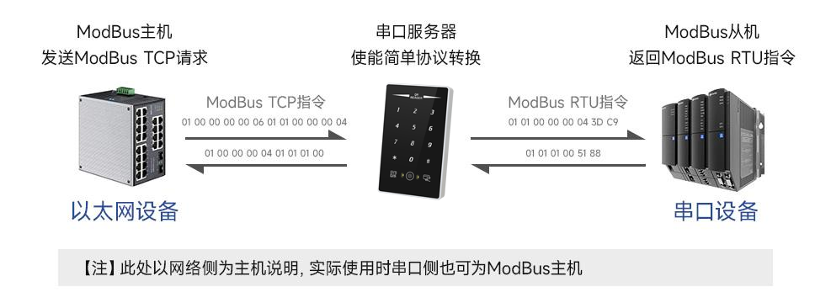
Host/web configuration:
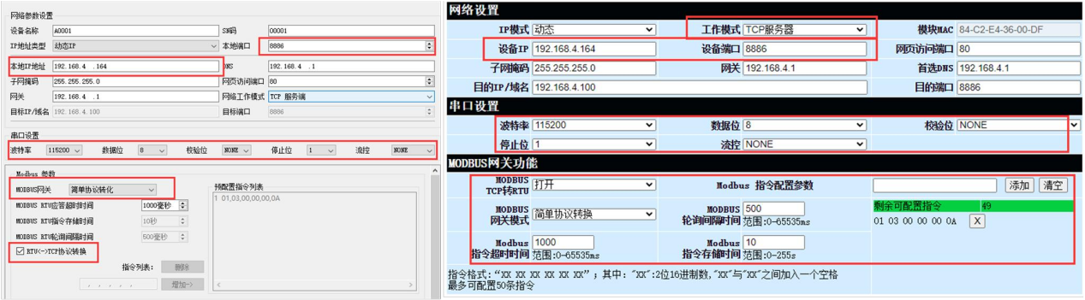
Modbus Poll and Modbus Slave software debugging:
Software connection settings:
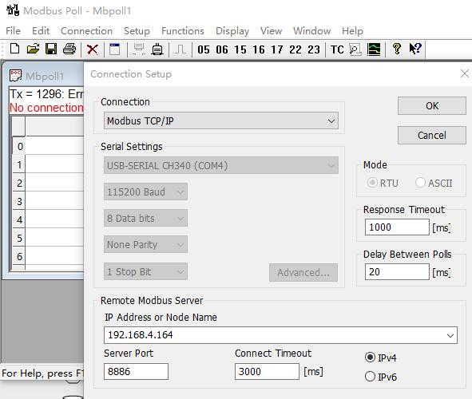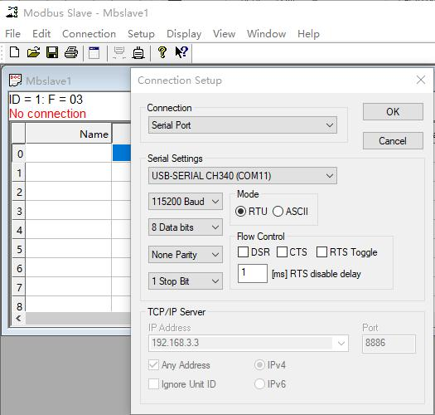
Software register reading and simulation configuration:
Poll menu selection Setup → Read/Write Definition
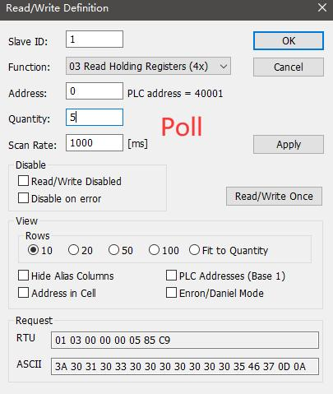
Slave menu selection Setup → Slave Definition
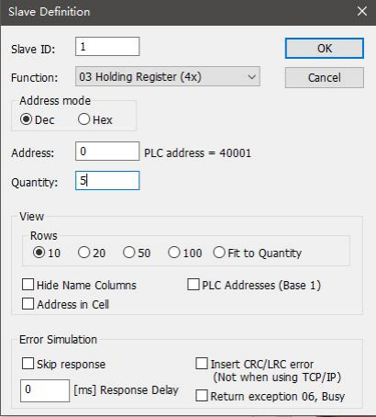
Communication demo:

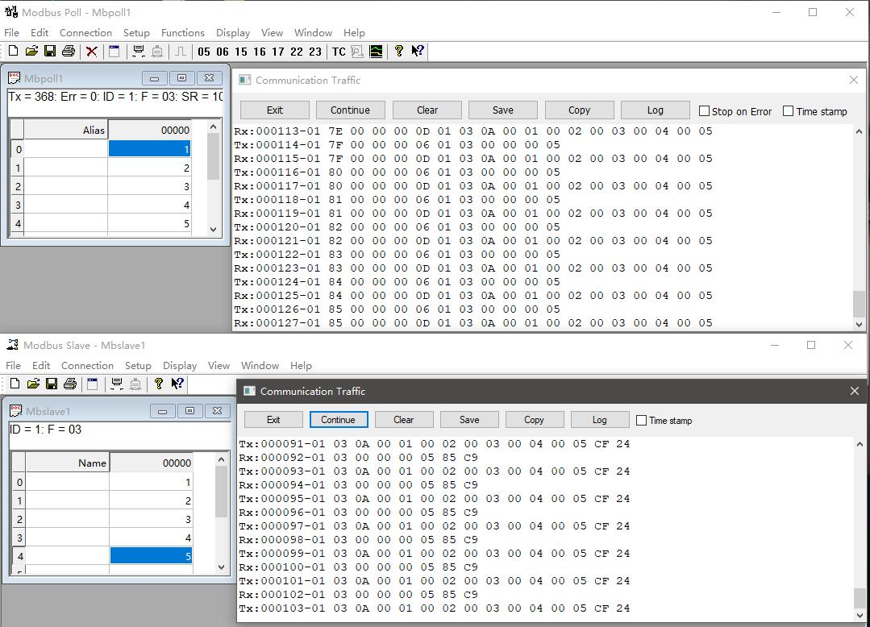
Multi-Host Mode
The relatively simple protocol conversion only supports a single Modbus master station, whereas the multi-host mode can handle up to 6 Modbus devices.
TCP host: When multiple Modbus hosts simultaneously access the Modbus gateway, the system performs bus occupancy scheduling (RS-485 bus).
The line can only process one request at a time, whereas the multi-host mode handles requests in order of TCP request sequence, with other links entering...
The system operates in a queue-based manner to resolve bus collision issues (currently supporting only 6 host connections) and is designed exclusively for TCP server mode operation.
The slave device must operate only through a serial port; otherwise, it will fail to function properly.
It is recommended to configure it as "Simple Protocol Conversion" when no multi-host usage is required.
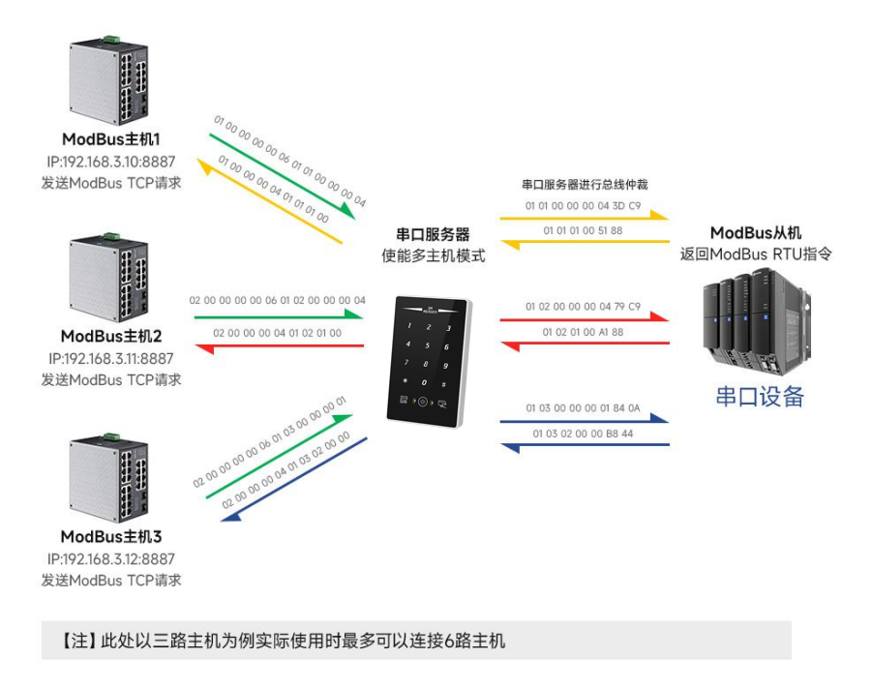
Host/web configuration:
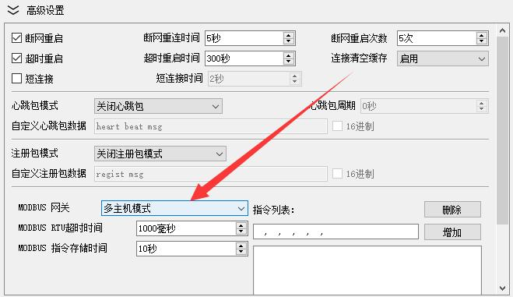
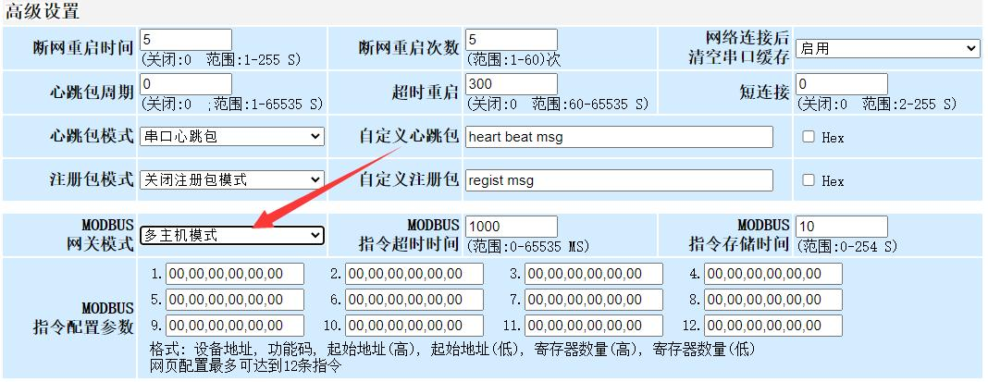
Modbus Poll and Modbus Slave software debugging:
For software and register configuration, refer to "Simple Protocol Conversion", and enable multiple Modbus Poll software instances (e.g., 3 channels, with support up to 6 channels).
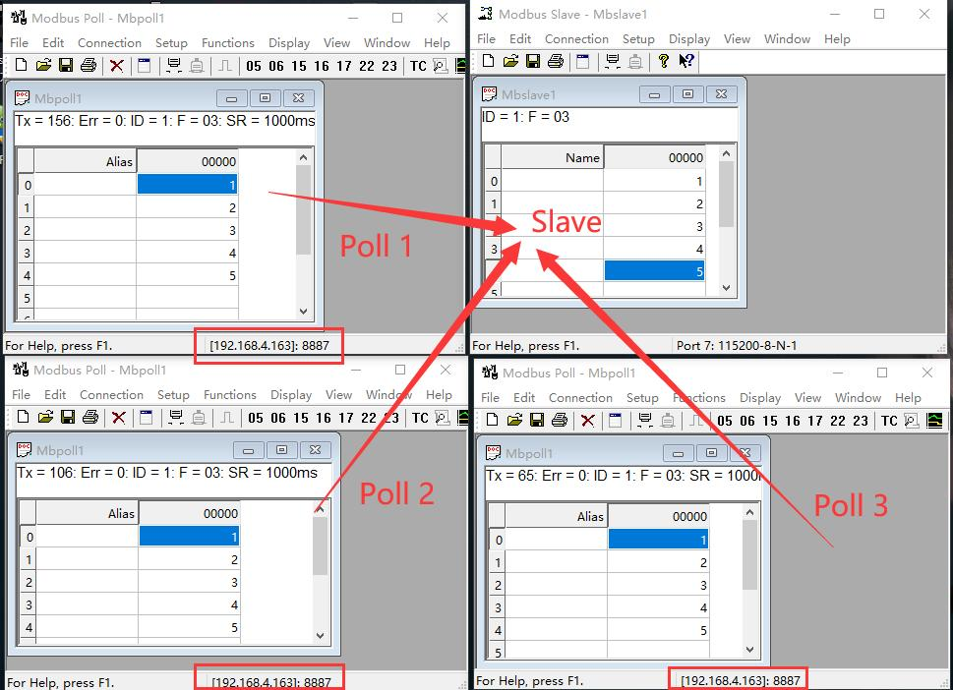
storage gateway
The storage gateway not only performs arbitration on bus data but also stores duplicate read instructions. When multiple hosts request identical data, the gateway eliminates the need to repeatedly check RTU device register statuses, instead directly returning cached data from storage areas. This significantly enhances the gateway's multi-host request processing capability while reducing overall request processing time. Users can customize storage instruction polling intervals and instruction storage durations according to operational requirements.
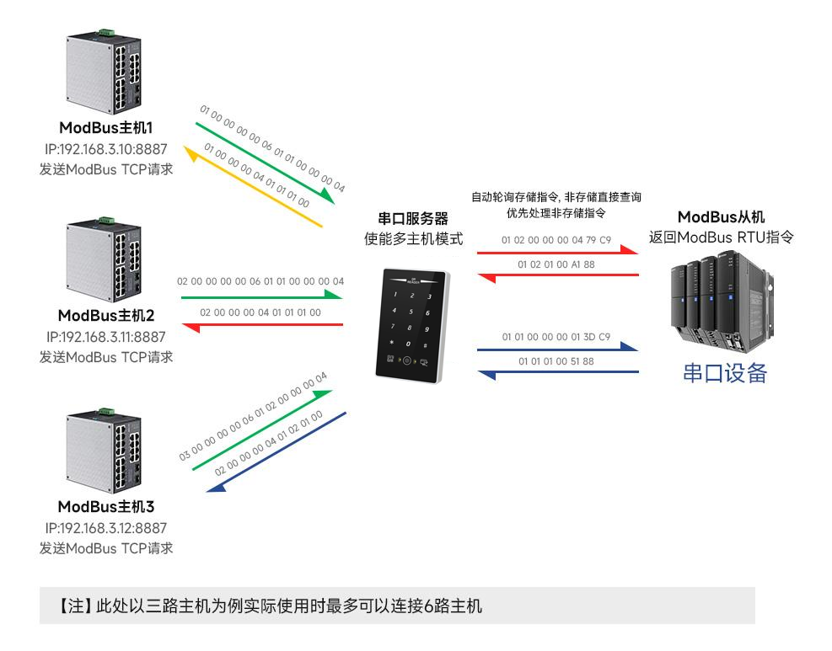
The storage gateway, designed to optimize performance for multi-host requests, operates exclusively in TCP server mode, significantly enhancing network-side response speed.
characteristic ：
(1) The gateway features 5K cache memory for storing instructions and returning results (for example, reading from 10 hold registers).
can store 189 instructions and return results);
(2) The RTU automatically clears its buffer upon response timeout to ensure data real-time performance and authenticity;
(3) The polling interval can be customized, ranging from 0 to 65535ms;
(4) The gateway stores time-polling RTU devices based on configuration instructions, and the MODBUS host maintains this storage duration.
When the gateway receives another query for this command, it automatically deletes the stored command and releases the cache.
(5) The first instruction and control instructions (function codes 05,06,0F, and 10) directly access the RTU device.
(6) Only supports storage of query results for Modbus function codes 01,02,03, and 04;
Storage gateway host and web configuration:
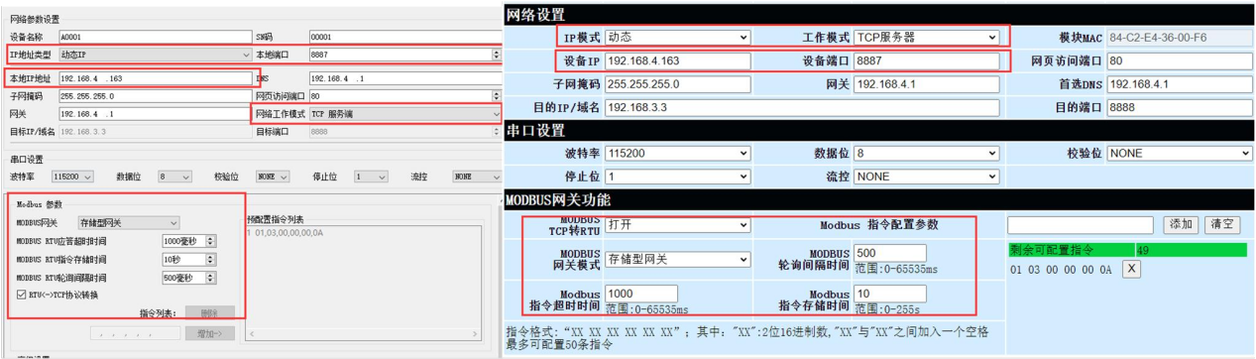

Configurable gateway
The gateway automatically polls RTU device registers based on preconfigured MODBUS commands (only for configurations supporting MODBUS read commands). Non-storage-table commands directly interact with RTU devices. Frequently read commands can be pre-stored within the gateway.
It can reduce response time (for configuring query commands). Due to these features, the serial port side of a configurable gateway can only connect to Modbus slaves.
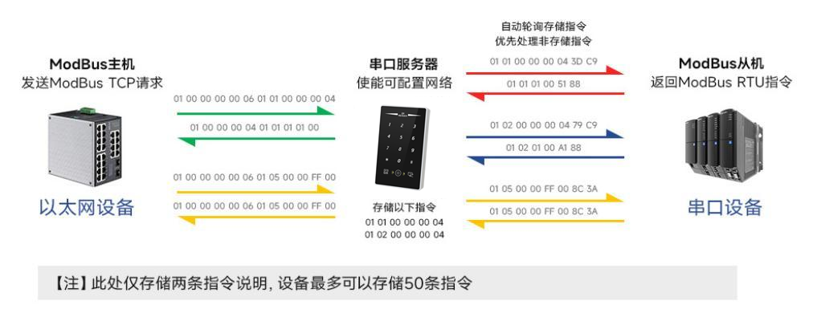
Instruction memory description (added: instruction errors and format errors cannot be added):
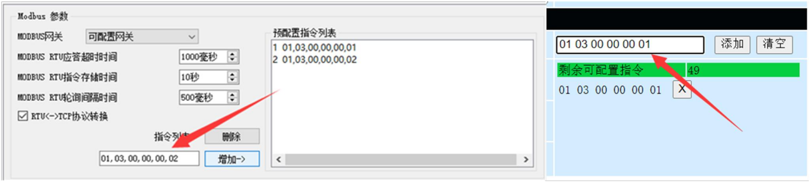
Instruction memory description (deleted):
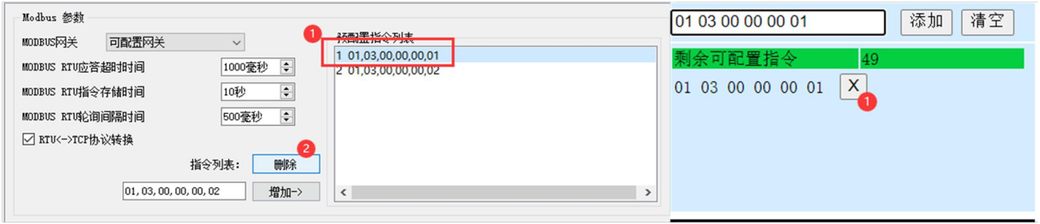
Host/web configuration:
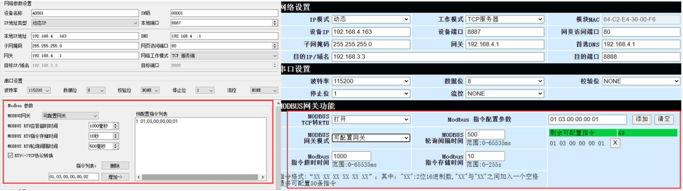
Auto Upload
In client mode (TCP client, UDP client, MQTT client, or HTTP client), the gateway automatically polls instructions from the storage command table and uploads them to the server. Users can select feedback formats (Modbus RTU or Modbus TCP) and command polling intervals (0-65535ms) based on requirements.
For instruction pre-storage, refer to "Configurable Gateway-Instruction Storage Guide". The system automatically uploads configurations from the host computer or web interface.
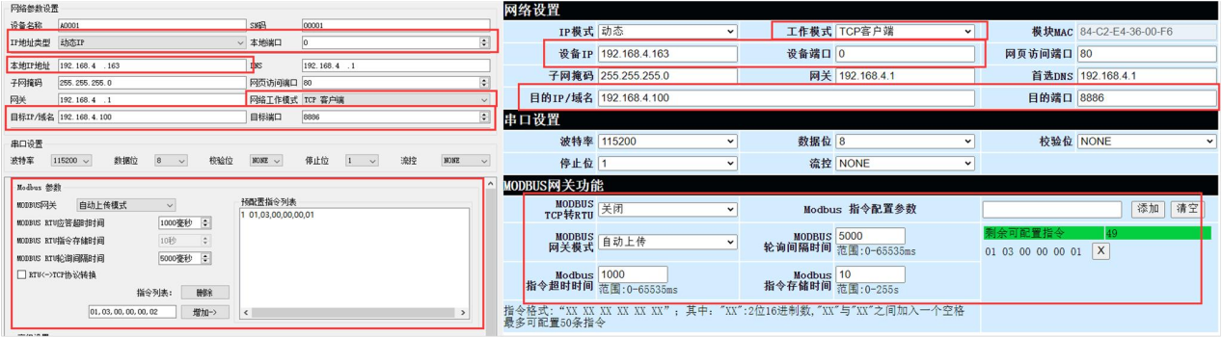
TCP client demonstration (Modbus RTU format):
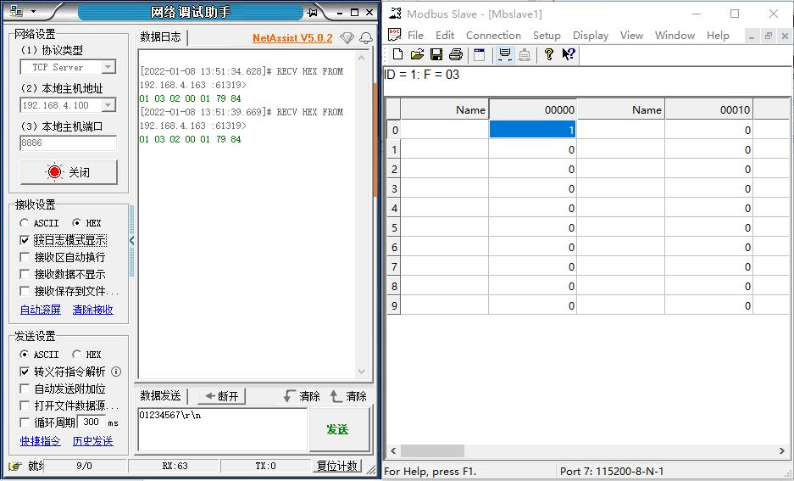
TCP client demonstration (Modbus TCP format):
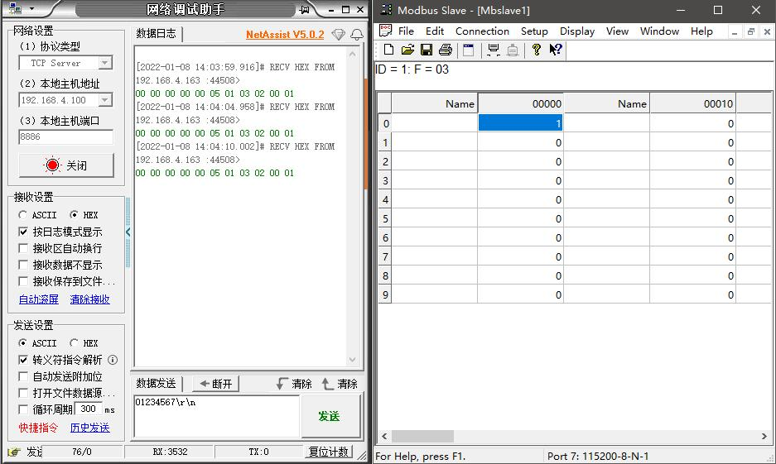
MQTT client demonstration (Modbus RTU format):
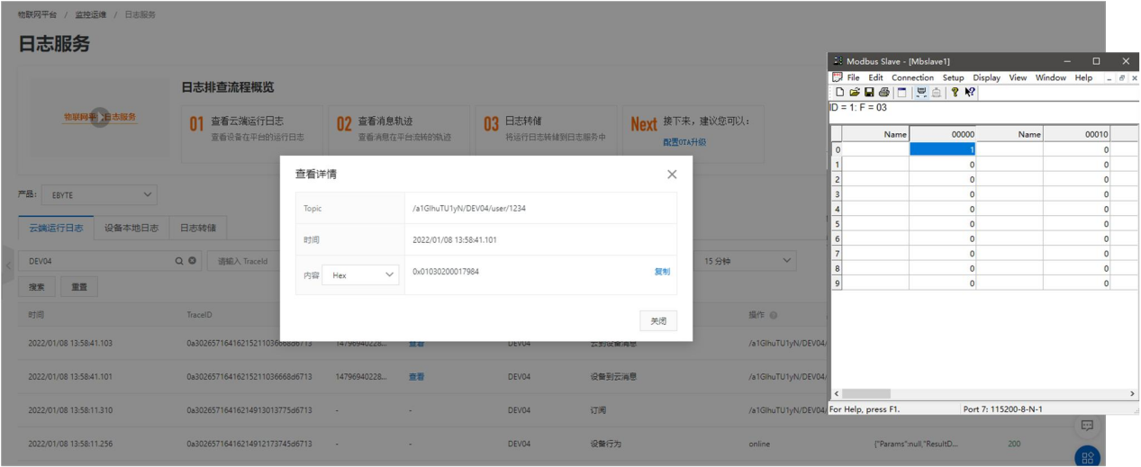
MQTT client demo (Modbus TCP format):
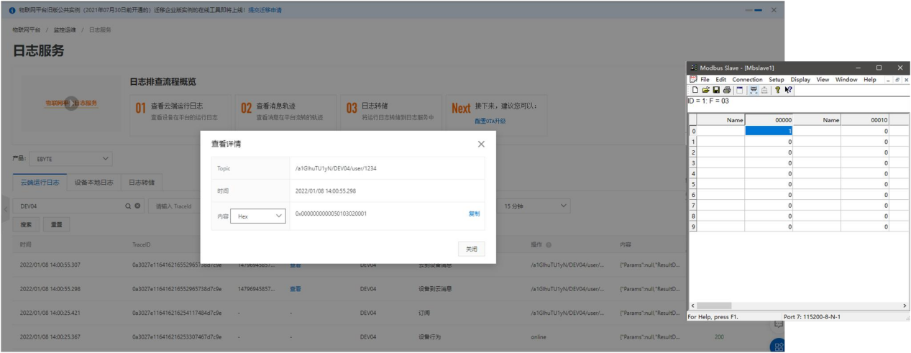

Advanced Functions
Random local port
TCP clients, UDP clients, HTTP clients, and MQTT clients can configure their local ports to 0 (using random local ports). The server mode cannot utilize random ports, as this would prevent clients from establishing connections properly. Using random ports enables rapid reconnection when devices unexpectedly disconnect from the server, avoiding connection rejections caused by incomplete four-way handshake. It is recommended to use random ports in client mode.
The device automatically enables random ports when configured with TCP client, HTTP client, or MQTT client modes.
Heartbeat pack function
In client mode, users can choose to send heartbeat packets with customizable transmission intervals. The heartbeat packets support two modes: network heartbeat packets and serial port heartbeat packets, compatible with hexadecimal and ASCII encoding. Note that these heartbeat packets are not MQTT heartbeats and must be disabled in MQTT client mode. For MQTT heartbeats, simply configure the KeepAlive time in "MQTT Function Settings" – it is recommended to set it to at least 60 seconds, as suggested by Alibaba Cloud documentation (e.g., 120 seconds).
Heartbeat packet sending mode:
(1) Heartbeat packet mode is disabled by default.
(2) Serial port mode-> The device sends heartbeat data to the serial bus at preset heartbeat intervals.
(3) Network interface mode-> The device sends heartbeat data to the network interface bus at preset heartbeat intervals.
Customize heartbeat packet content (supports up to 40 bytes (ASCII) or 20 bytes (HEX) data)
Customize the heartbeat packet sending interval. Set to 0 to disable the heartbeat packet function, or set a value greater than zero to enable it. The enabled interval ranges from 1 to 65536 seconds, with the default value being 0.
Subscription Package Feature
In client mode, users can choose to send registration packages and customize the package delivery time.
The registration package supports the following modes:
(1) The network sends MAC addresses (OLMAC) when establishing connections with devices.
(2) The network transmits data from the custom registration packet (OLCSTM) when establishing a connection with the device.
(3) After establishing a connection between the network and the device, each data packet transmitted by the device to the network is prefixed with the MAC address (EMBMAC).
(4) After the network and device establish a connection, each data packet sent by the device to the network is prefixed with custom registration packet data.
（EMBCSTM）
Customize registration package content (supports up to 40 bytes (ASCII) or 20 bytes (HEX) data)
Timeout restart feature
Supports timeout restart functionality (default: 300 seconds). This feature primarily ensures long-term stable device operation. Set timeout
If no data transmission occurs during the reboot period, the device will restart to prevent communication disruptions caused by anomalies.
The timeout restart time parameter ranges from 60 to 65535 seconds. Setting it to 0 disables timeout restart. The default is 300 seconds.
Cache cleanup feature
The device operates in client mode. When no TCP connection is established, data received through the serial port is stored in a 1024-byte buffer. Any data exceeding this size will overwrite the oldest received data. After establishing a network connection, you can configure the system to either clear the serial port buffer or transmit the buffered data over the network.
Enable: The device does not save data received via serial port before connection establishment.
Disabled: The network will receive serial port buffer data after connection establishment.

Disconnect and reconnect
In client mode, the device attempts to reconnect to the server at a specified interval after a network disconnection. If the request times out and the device fails to reconnect after reaching the preset retry limit, it will restart to prevent network connectivity loss following a device disconnect.
Disconnection and reconnection time: The interval between each attempt by the device to re-establish the network.
Reconnection attempts: The number of times the device tries to reconnect to the network. If the cumulative number of attempts reaches the preset threshold without a successful connection, the device will automatically restart.
The actual reboot time is calculated by multiplying the network disconnection reconnect cycle by the reconnect attempts. For general use, the factory default settings are recommended.

Remote Upgrade
To facilitate future maintenance, feature upgrades, and firmware replacement, serial port servers (including NA11x series, NB114, NS1, NT1 models) support online firmware updates. Using our provided upgrade firmware, users can perform firmware upgrades or replacements via host computers.
Network upgrade firmware steps:
Step 1: Launch the host computer, open the Device Upgrade Assistant from the menu bar, and select the required firmware (firmware is available for download from the official website).
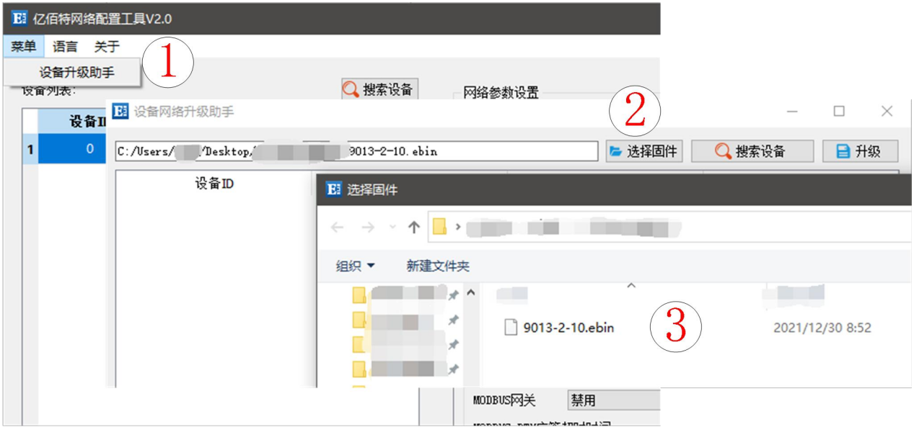
Step 2: Click Search Device, locate the device, then click Stop Search.
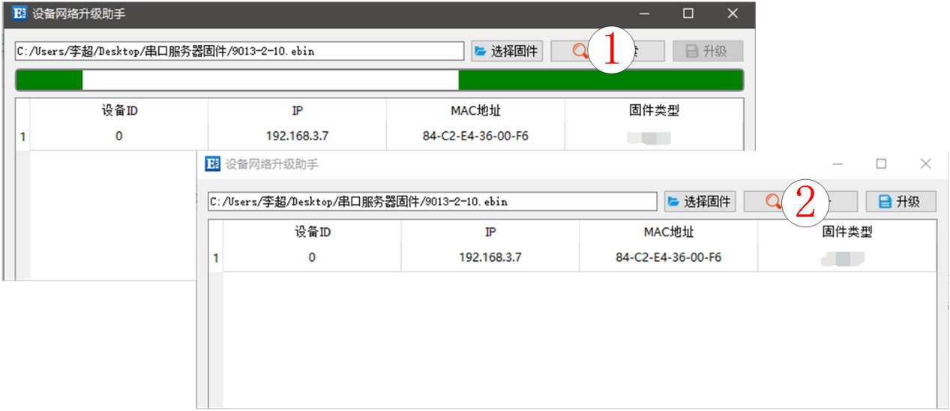
Step 3: Select the device to upgrade;
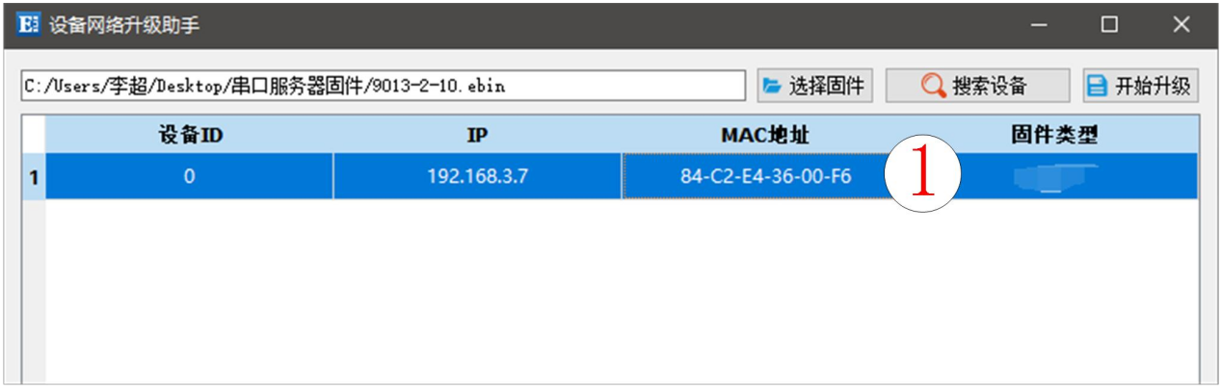
Step 4: Click Start Upgrade. The device indicator light will flash. Wait for the upgrade to complete.
Note: When the device is powered on, click "Search Device" in the Upgrade Assistant to enter firmware flashing mode. The device will resume after power-off restart.
normal mode 。


